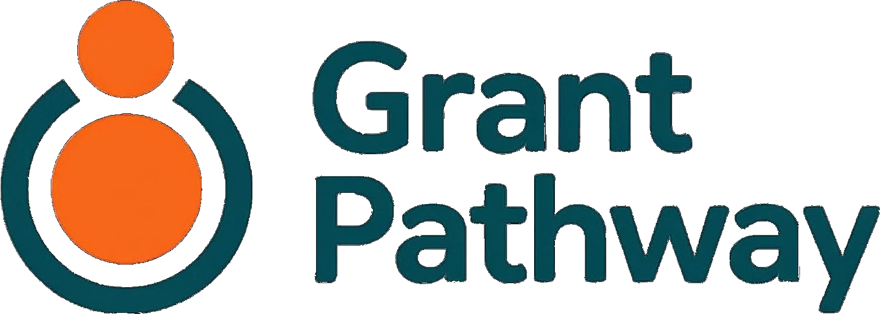
User Guide

A step-by-step guide to preparing your grant application
Service provided by :
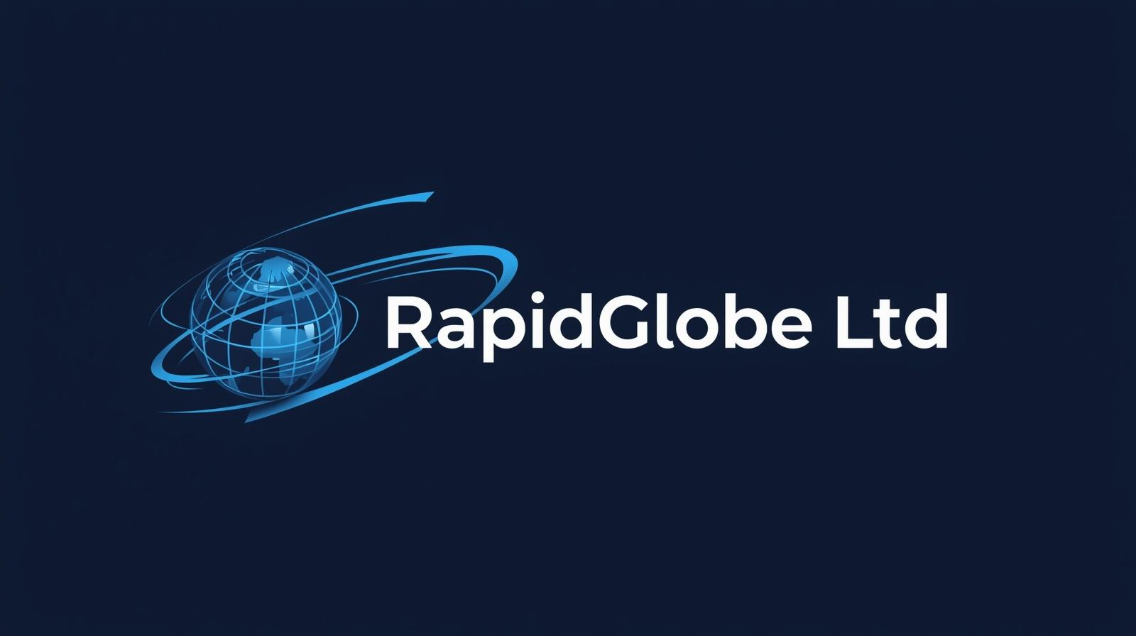
July 2026
Version 1.19

Contents
1. Welcome to Grant Pathway 3
2. How Grant Pathway Works 3
3. How to Use This Guide 3
4. Before You Start 3
5. Creating Your Account 4
6. Setting Up Your Charity Profile 6
7. Signing In 9
8. Your Dashboard 9
9. Choose Your Funder and Grant 10
10. Upload the Funder's Guidelines 10
11. Review the Summary 12
12. Before You Begin Writing 14
13. Write Your Answers 15
14. Prior Export 19
15. Review 19
16. Export 20
17. Managing Your Account 20
18. Application Status — What the Labels Mean 23
19. Need Help? 23

1. Welcome to Grant Pathway
Grant Pathway helps your charity prepare stronger grant applications. It reads a funder's guidelines, pulls out the key questions they want you to answer, and gives you a structured space to write — and refine — each answer with optional AI support.
Every word in your application is written by you. Grant Pathway helps you stay organised, keep within word limits, and polish your answers before you export them as a ready-to-submit Word document.

2. How Grant Pathway Works
The diagram below shows the four stages of preparing an application with Grant Pathway, from setting up your profile through to exporting your finished document.
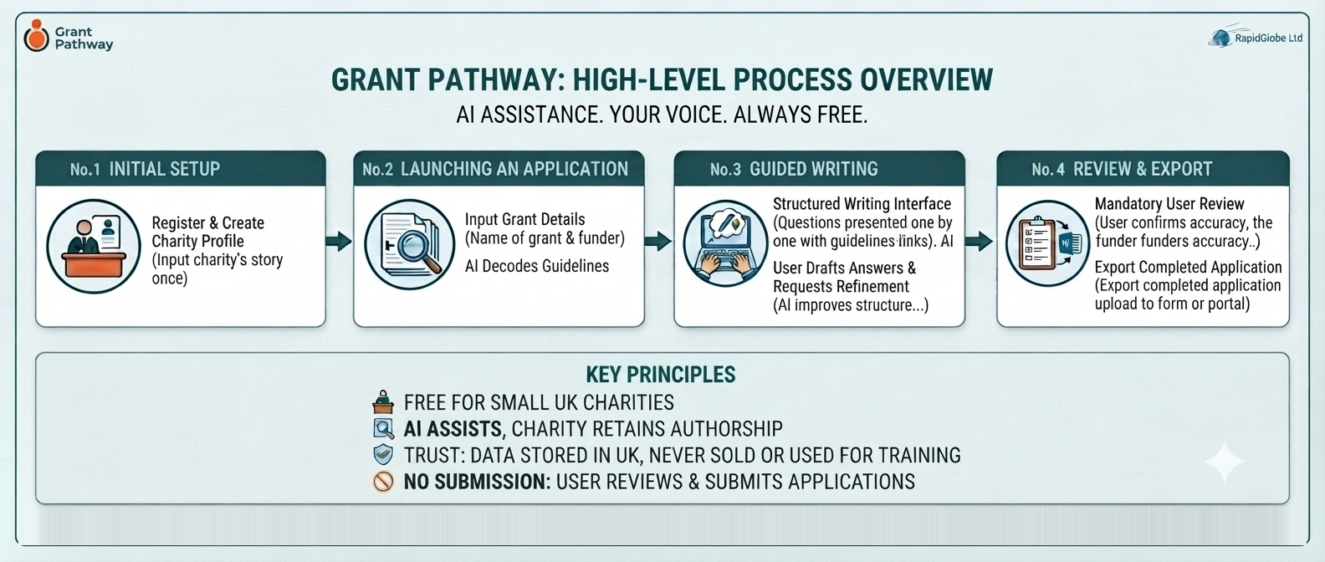

3. How to Use This Guide
This guide takes you through Grant Pathway in the order you'll actually use it — from first sign-up right through to exporting your finished application.
Already have an account?
If you have already created your account and set up your charity profile, you can skip straight to Section 7 — Signing In to start your next application.

If this is your first time using Grant Pathway, continue with Section 4 to get set up.

4. Before You Start
Grant Pathway can help you apply to any funder. Simply upload or paste in that funder's guidelines when you reach Section 10, and Grant Pathway's AI will read them and identify the questions you need to answer.
Please have the funder's guidelines document accessible — you will need it at Section 10. It can be a Word or PDF file. If you don't have one, copy the relevant sections from the funder's website and paste them in instead.
- Have your charity name and registration number to hand.

5. Creating Your Account
Go to grant-pathway-three.vercel.app and click Register — it's free in the top right corner.
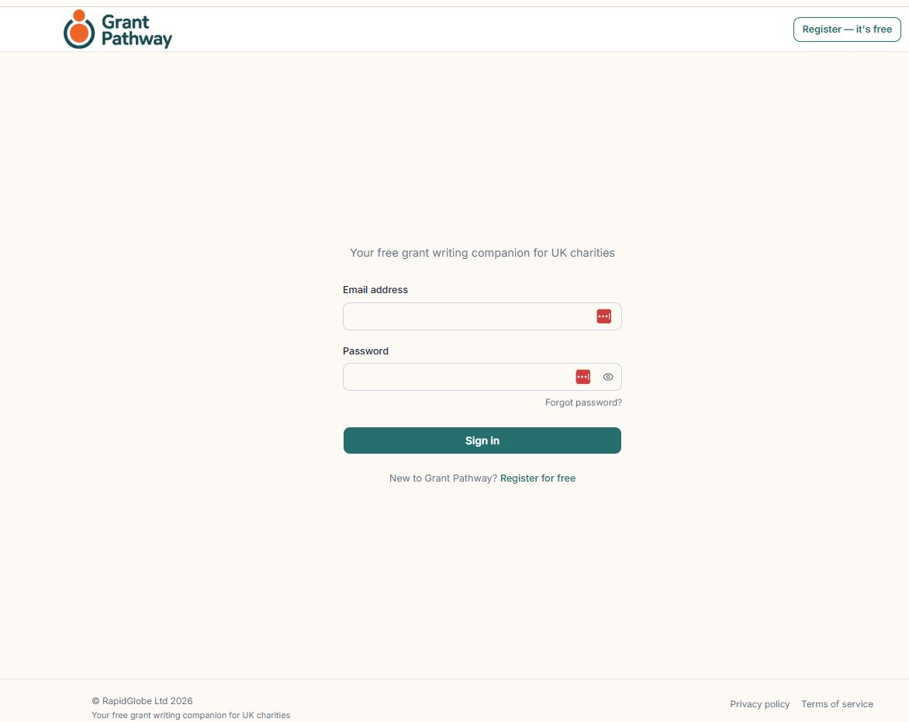
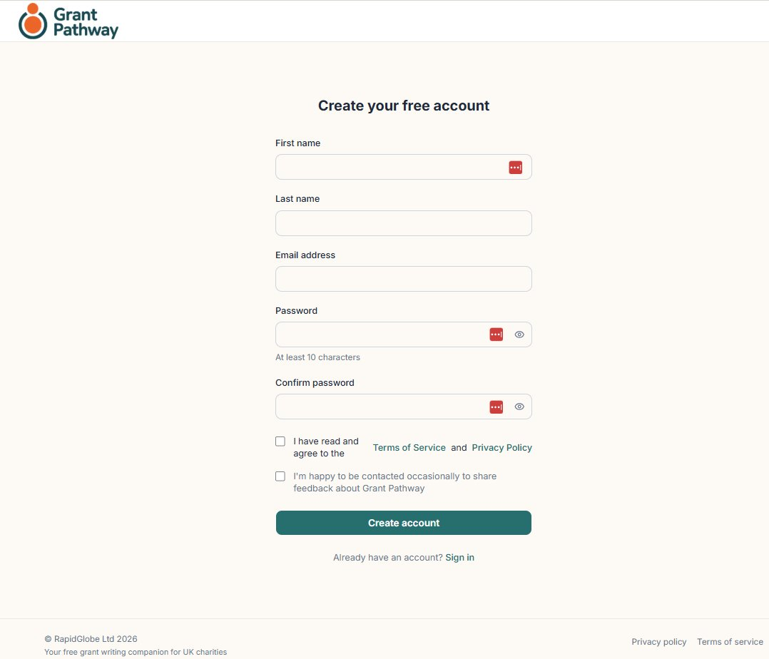
Fill in the following fields:
- First name / Last name
- Email address — use your work email address. This will be your login.
- Password — choose a password of at least 10 characters.
- Confirm password
- Terms of Service and Privacy Policy — tick to confirm you have read and agree to both.
- I'm happy to be contacted occasionally to share feedback about Grant Pathway — tick this optional box if you are happy to be contacted for feedback purposes.
Click Create account. Grant Pathway will send a verification link to your email address.
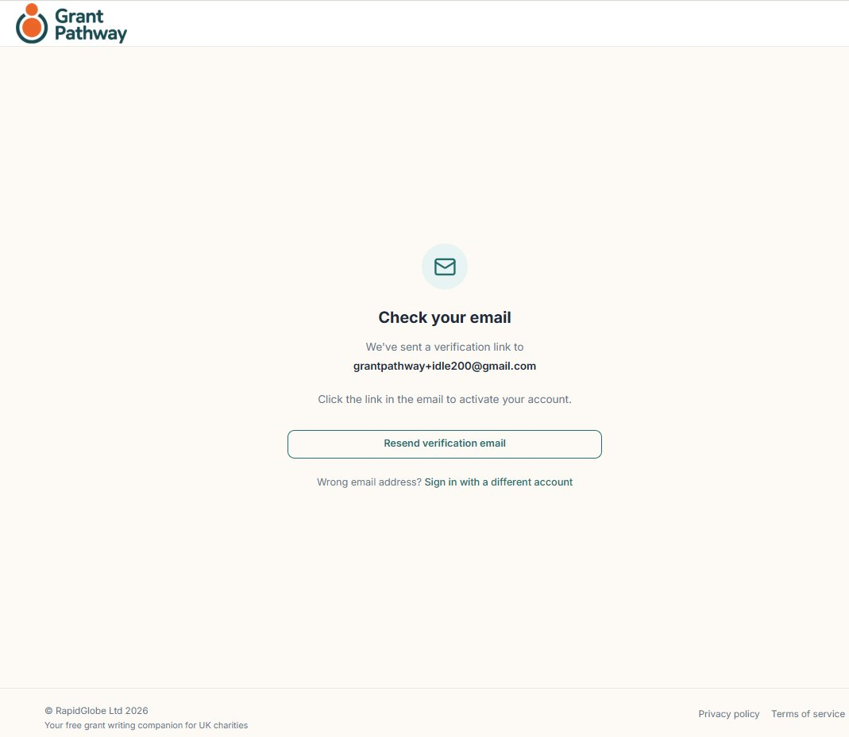
Click the link in the email to activate your account. If the link has expired, click Resend verification email on the screen that opens.
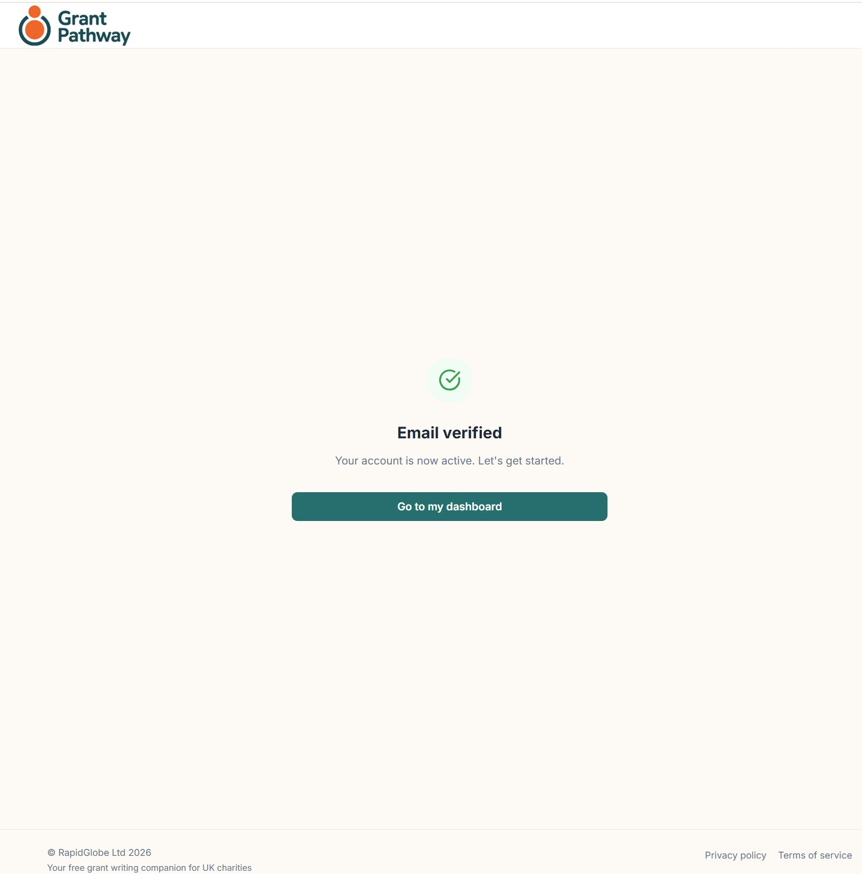
Once your email is verified, you will see a confirmation screen. Click Sign in and enter your email address and password to continue — the verification link does not sign you in automatically.
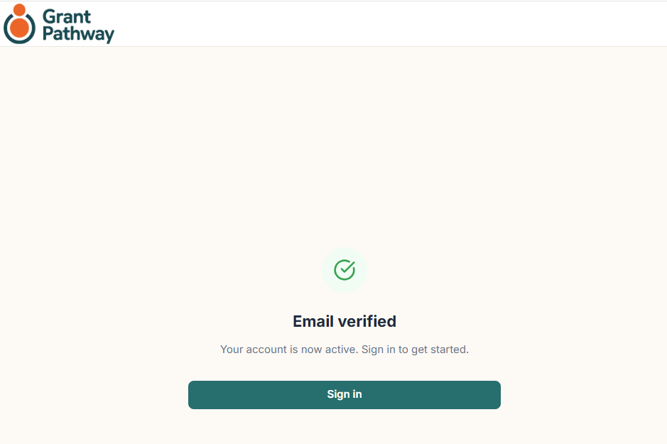

6. Setting Up Your Charity Profile
When you first sign in, a banner will prompt you to complete your charity profile — you must do this before starting an application. Click Complete your profile to open the profile form. You can also return to it at any time via the Charity profile link in the navigation bar.
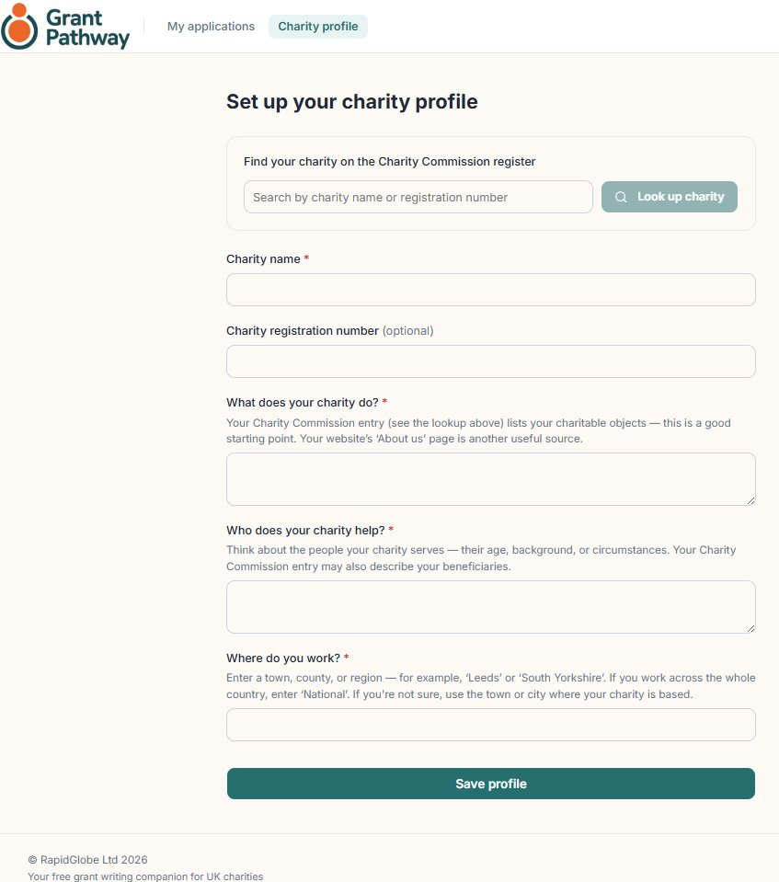
The information in your charity profile is used to personalise the AI-generated content in your applications.

Enter the charity name or registration number in the search box, then click Look up charity.
If the charity is found on the Charity Commission database, What does the charity do and Who does your charity help will be populated automatically. Complete the Where do you work section, then click Save profile.
If the charity is not found, complete the following fields manually, then click Save profile:
- Charity name
- Charity registration number (optional)
- What does the charity do
- Who does the charity help
- Where do you work
Grant Pathway will display a “Profile saved” confirmation screen with the message: “Your charity profile has been saved. You're ready to start your first application.”
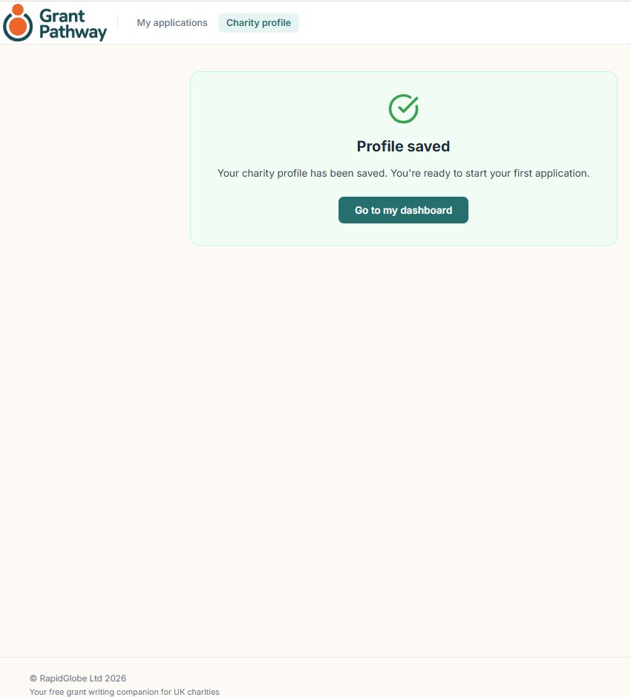
Click Go to my dashboard.
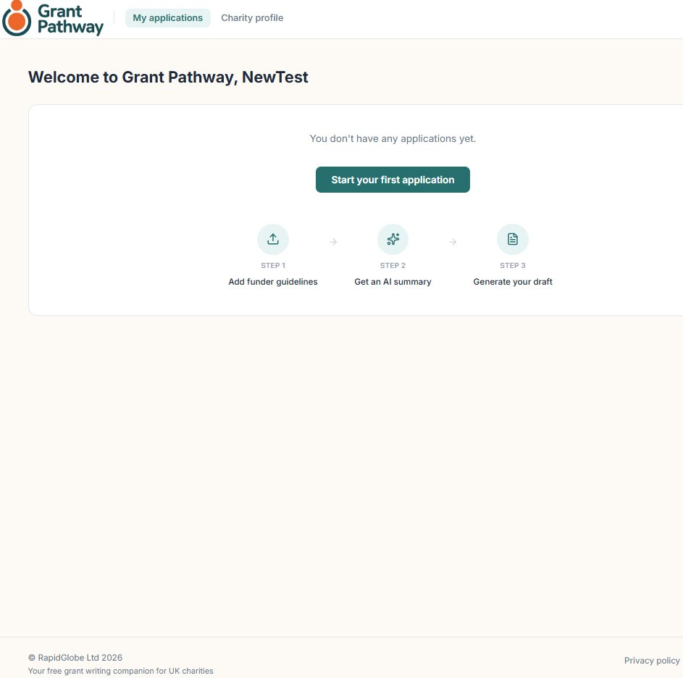
Click Start your first application to begin and then go to Section 9 — Choose Your Funder and Grant.

7. Signing In
Go to grant-pathway-three.vercel.app. Enter your Email address and Password, then click Sign in.
If you have forgotten your password, click Forgot password? and follow the instructions to reset it.

8. Your Dashboard
Once signed in, your dashboard displays all your applications. Each application shows the funder name, the grant name, its current status, and the date it was last updated.
To start a new application, click + New Application.
To continue working on an existing application, click View.
To remove an application you no longer need, click Delete.
The summary bar at the top of your applications list shows how many applications you have at each stage, and how many AI requests you have used this month.
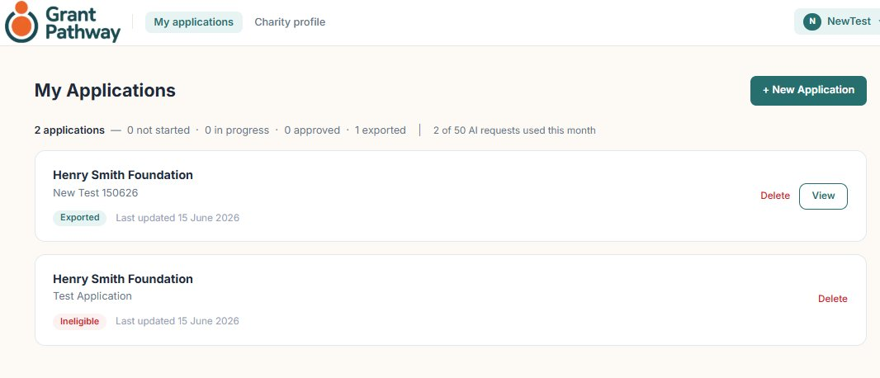
Click + New Application to begin a new application.

9. Choose Your Funder and Grant
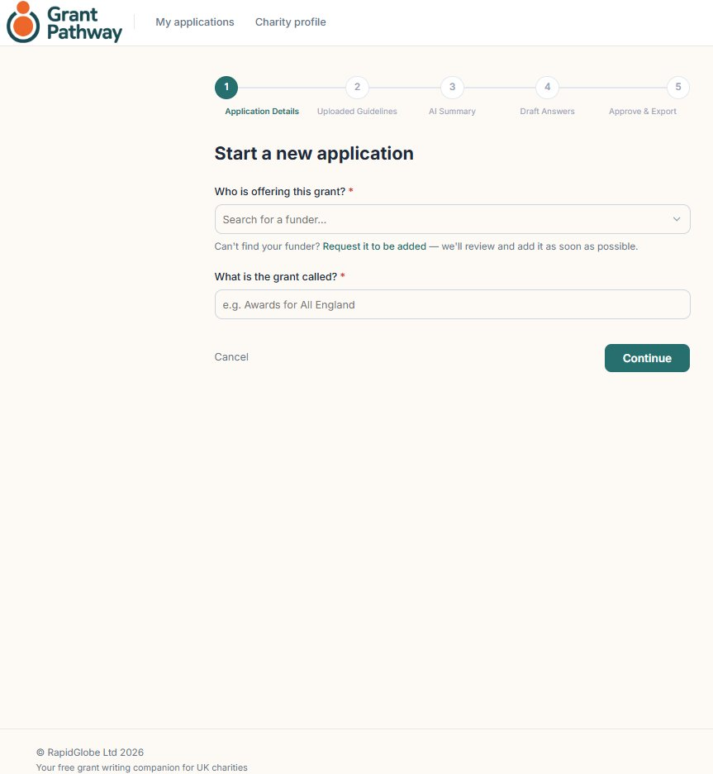
- Funder — type the name of the grant-giving organisation you are applying to.
- Grant name — type the name of the specific grant programme you are applying for (e.g. “Community Grants Programme 2026”). This is for your records and does not affect the application.
Click Continue to proceed.

10. Upload the Funder's Guidelines
Grant Pathway reads the funder's guidelines to understand what questions they want you to answer and what they are looking for.
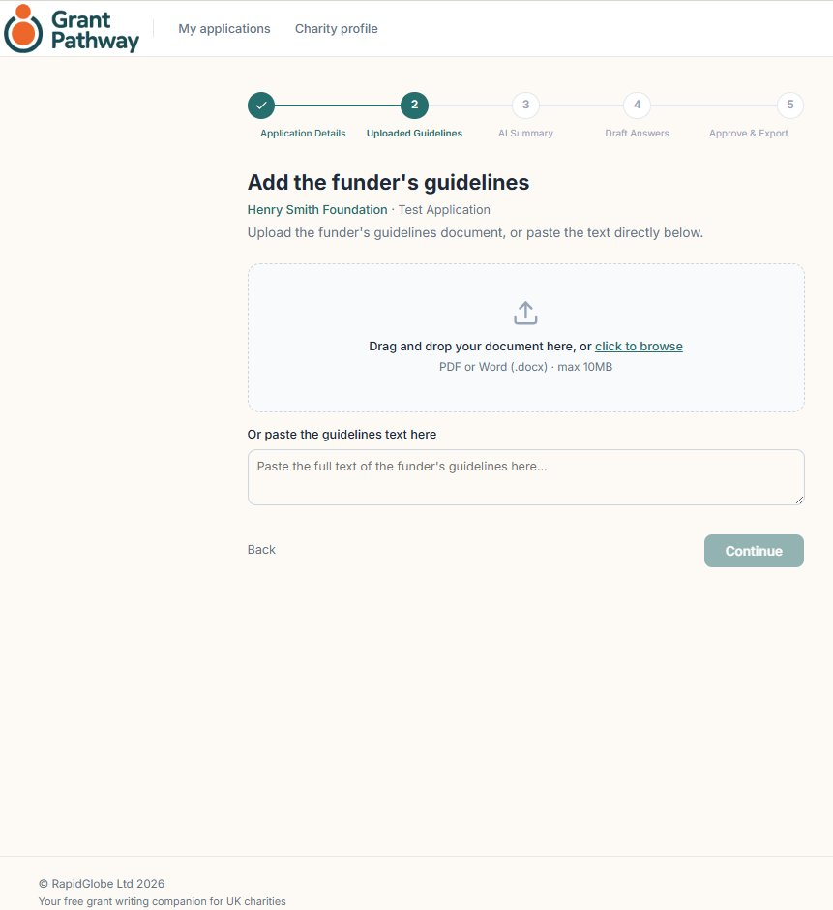
You have two options:

UPLOAD A FILE
Click Choose file or drag and drop a PDF or Word document onto the upload area. This works best when the funder provides a downloadable guidelines document.

PASTE TEXT
If the funder's questions are on their website, click the Paste text tab and paste the relevant text into the text box.
Tip:
For the best results, upload or paste the section of the guidelines that contains the application questions and assessment criteria. You do not need to include the funder's background information or terms and conditions.

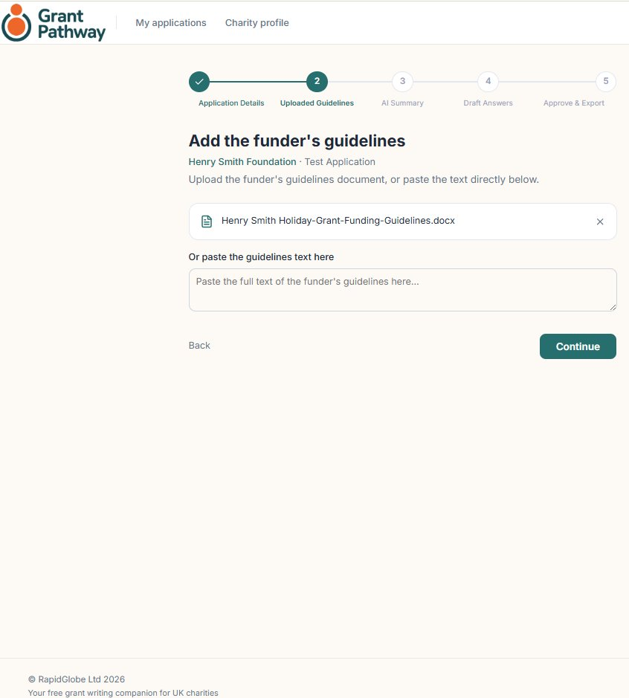
Once your guidelines are uploaded or pasted, click Continue.

11. Review the Summary
The Grant Pathway AI engine analyses the guidelines and produces a summary. This usually takes up to 45 seconds.
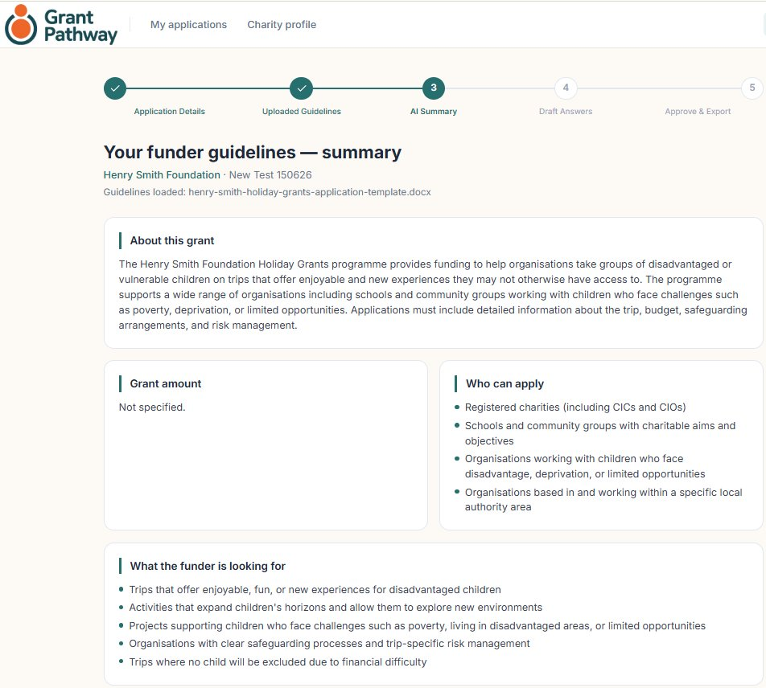
The summary screen includes:
- About this grant
- Grant amount
- Who can apply
- What the funder is looking for
- Application sections
- Key requirements
Grant Pathway will identify the sections that need to be completed before the application is submitted to the grant-issuing organisation.
When you are ready, click Continue.

Note: Eligibility mismatch
In some cases, Grant Pathway may determine that your charity is not eligible for the selected grant. If this happens, you will see an eligibility mismatch message at Step 3 — AI Summary, explaining why your application cannot proceed. Read the message carefully — it will explain the specific reason. You can then either update your Charity profile to better reflect your charity's work, then start a new application, or select a different funder whose criteria more closely match your charity's work. Click “I understand — return to my dashboard” to go back and start again.

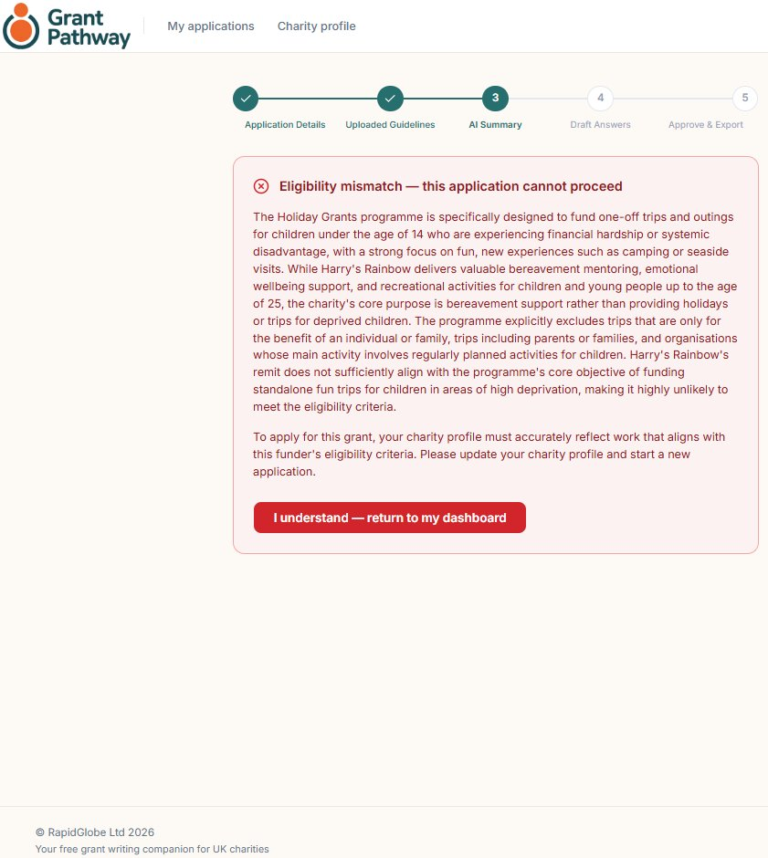

12. Before You Begin Writing
Grant Pathway will prompt you to ensure all relevant financial information is to hand before you begin writing.
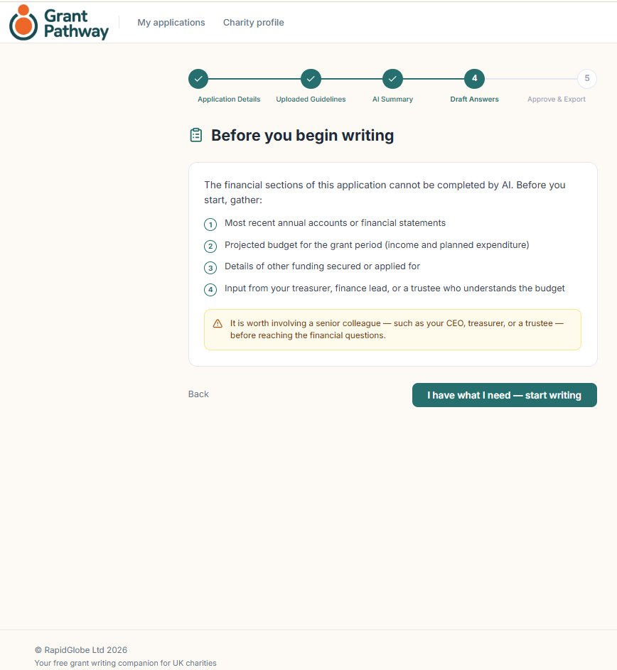
Tip:
Grant Pathway allows up to 50 AI-assisted requests per calendar month per account. This covers guideline summaries, draft generation, and answer refinement. A counter on your dashboard shows how many requests you have used. A warning will appear when you are approaching this limit.

When you are ready, click I have what I need – start writing.

13. Write Your Answers
Each question or section extracted from the guidelines appears as a separate card.
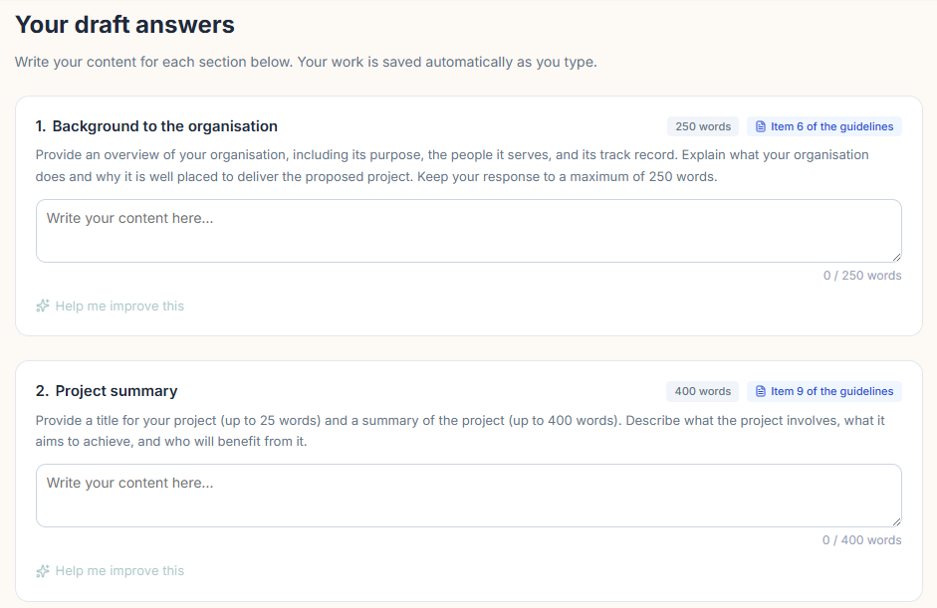

WRITING YOUR ANSWER
Click inside the answer box beneath each question and start typing. Your answer is saved automatically as you write.

WORD AND CHARACTER LIMITS
If the funder has set a word or character limit, it is shown on the question card. A counter below the text box tracks how many words or characters you have used.

GUIDELINES CITATIONS
Where a suggestion draws on a specific part of the funder's guidelines, Grant Pathway shows a short citation alongside it — pointing you to the exact requirement or wording it's responding to. This makes it easy to check that a suggestion is genuinely grounded in what the funder has asked for, rather than a generic rewrite.
Click a citation to see the relevant passage from the guidelines in full.
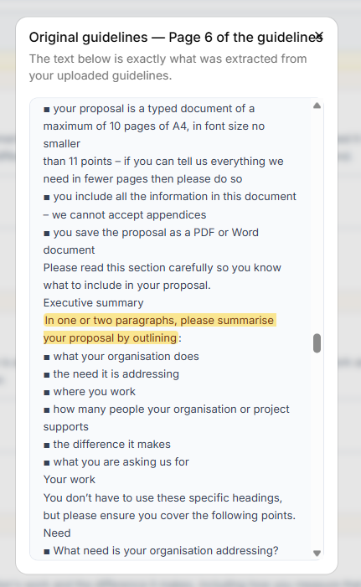

GETTING AI HELP
Click Help me improve this beneath any answer to ask the AI to refine the text. The AI will refine the structure and clarity of your answer while keeping your original wording and will try to bring it within the word or character limit if you are over limit.
AI can't always hit an exact word or character count, though — check the counter after accepting a suggestion, and trim further by hand if it's still over.
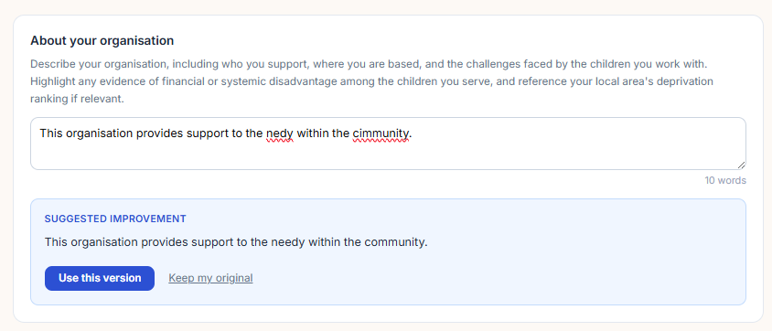
The AI may refine sentence structure and correct spelling but will not replace your content or change your intended meaning.
Once complete, you can choose to use the refined version or keep your original text.

SECTIONS WITH FINANCIAL INFORMATION
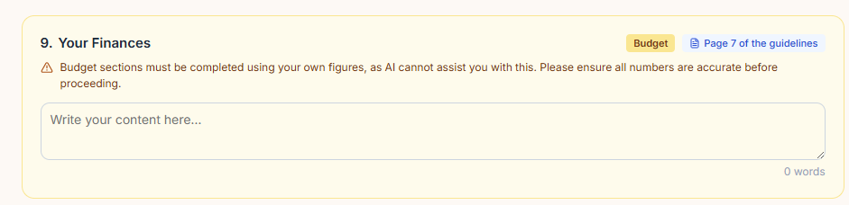

WRITING YOUR ANSWER
Click inside the answer box beneath each question and start typing. Your answer is saved automatically as you write.

WORD AND CHARACTER LIMITS
If the funder has set a word or character limit, it is shown on the question card. A counter below the text box tracks how many words or characters you have used.

GUIDELINES CITATIONS
Where a suggestion draws on a specific part of the funder's guidelines, Grant Pathway shows a short citation alongside it — pointing you to the exact requirement or wording it's responding to. This makes it easy to check that a suggestion is genuinely grounded in what the funder has asked for, rather than a generic rewrite.
Click a citation to see the relevant passage from the guidelines in full.

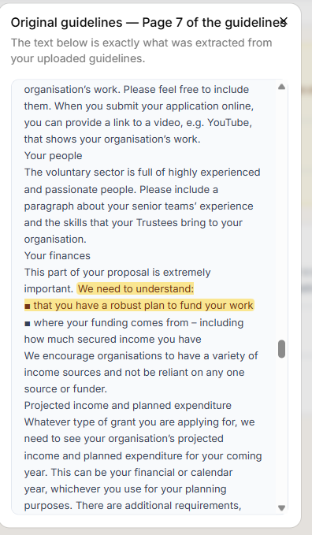

Note:
Sections containing financial information have no AI assistance available. Your text will appear exactly as entered, ensuring there is no uncertainty about AI involvement in the financial figures.

ADDING A FINANCIAL OR GOVERNANCE DETAIL
Some funders expect certain financial or governance information even when their guidelines don't explicitly ask for it. If this applies, you'll see a prompt: "Need to add something about your finances or governance that wasn't asked above? Add it."


Click Add it to see a list of common financial and governance questions — for example, whether any of your trustees are related to each other, or how many people are authorised as bank signatories. Tick any that apply to your charity, then click Add selected.
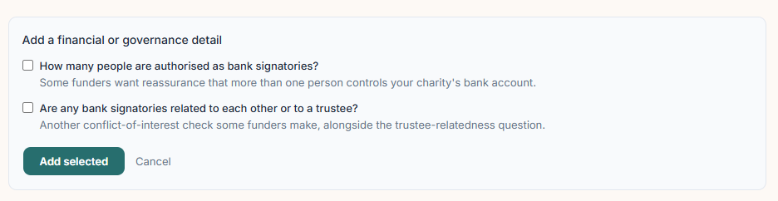
Each question you add appears as a new card near the top of your application, marked Added by you, and the section count at the top of the page updates to include it. If you don't have the information to hand yet, you can leave it as Not sure yet and come back to it later — like any other answer, it will need to be completed and approved before you can export.
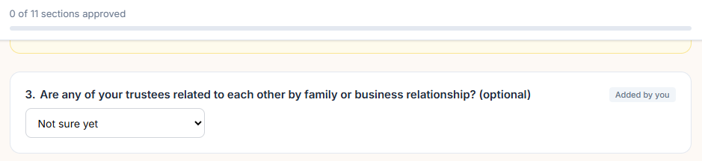

APPROVING ANSWERS
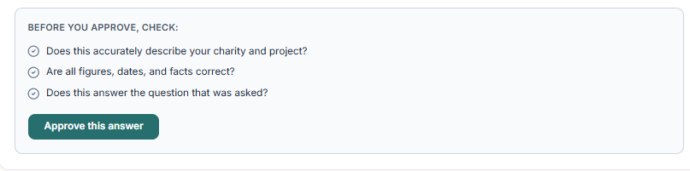
Once you have entered an answer, an approve option will appear.
Once you are happy with an answer, click Approve. The progress bar at the top of the page shows how many answers you have approved.
You must approve all answers before you can proceed to the next stage. If you edit an approved answer, the approval is removed and you will need to re-approve it.
The Ready to Assemble button will be inactive until all sections are approved. Once all approvals are in place, the button will become available.
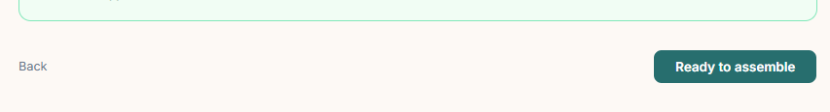

14. Prior Export
Before assembling the application, Grant Pathway will ask you to confirm that the financial content has been reviewed by a senior member of your team.
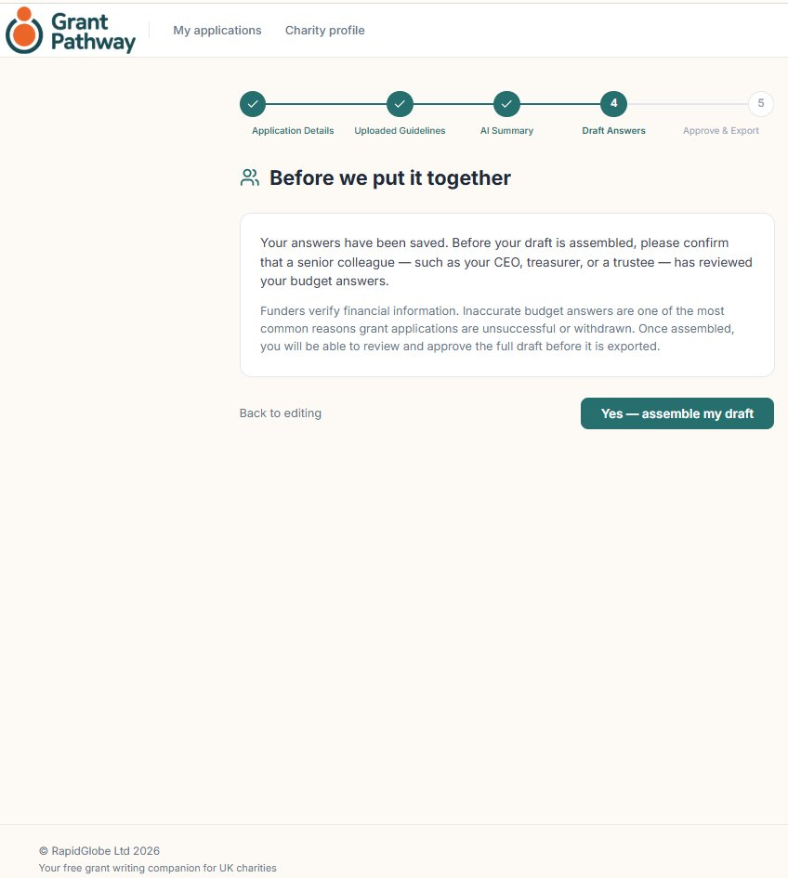
When you are satisfied that the financial information has been verified, click Yes — assemble my draft.

15. Review
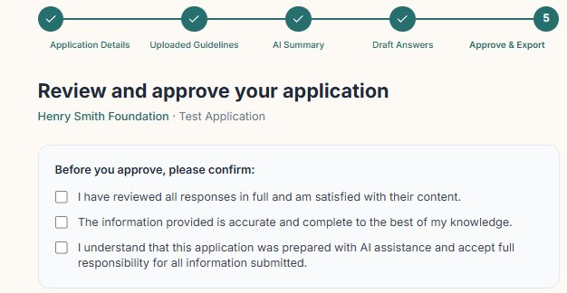
Before exporting, Grant Pathway will ask you to do a final review of your answers. Take a moment to review each answer. To make changes, click Back to return to the relevant section. Once you're satisfied, confirm your approval.

16. Export
Once you have given final approval, the download buttons will become available.
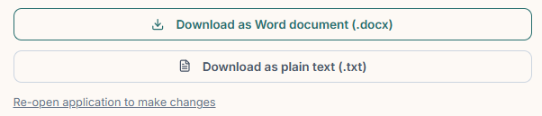
When you are ready, click Download as Word document to export your application. Grant Pathway produces a clean Word (.docx) file containing all your answers, formatted and ready for you to e.g. upload to the lenders portal, copy and paste into lenders word doc, etc.
Tip:
Save a copy of the Word document as soon as you download it. Grant Pathway stores your answers securely, but having a local copy is good practice before you submit.

17. Managing Your Account
To access your account settings, click your user icon in the top right corner of any page and select Account settings.
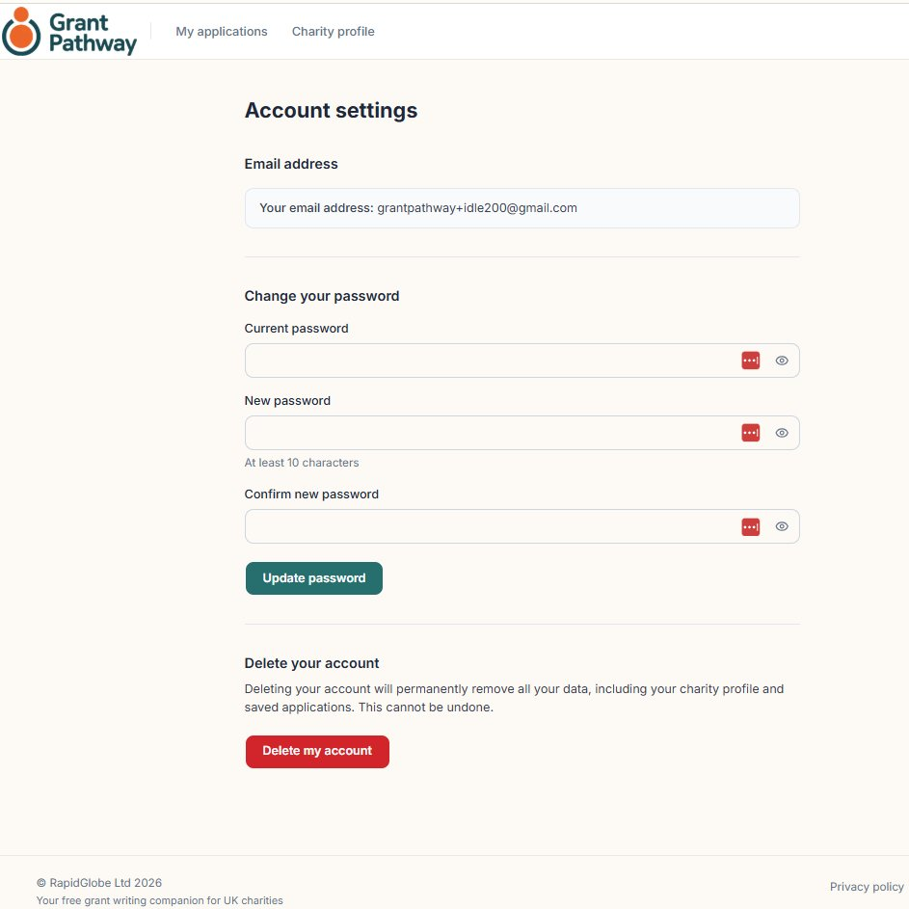
From the Account settings screen you can:
- Charity profile — update your charity's name, registration number, or descriptions at any time.
- Change your password — enter your current password, then your new password (at least 10 characters), and click Update password.
- Sign out — click Sign out to end your session.
- Delete your account — permanently removes all your data including your charity profile and all saved applications. See below.

DELETING YOUR ACCOUNT
Clicking Delete my account will take you to a confirmation screen. The following will be permanently deleted:
- Your charity profile
- All your grant applications and AI-generated content
- Your account and login details
To confirm, type DELETE in the confirmation box and click Permanently delete my account. This action cannot be undone. Click Cancel to return to Account settings without deleting.
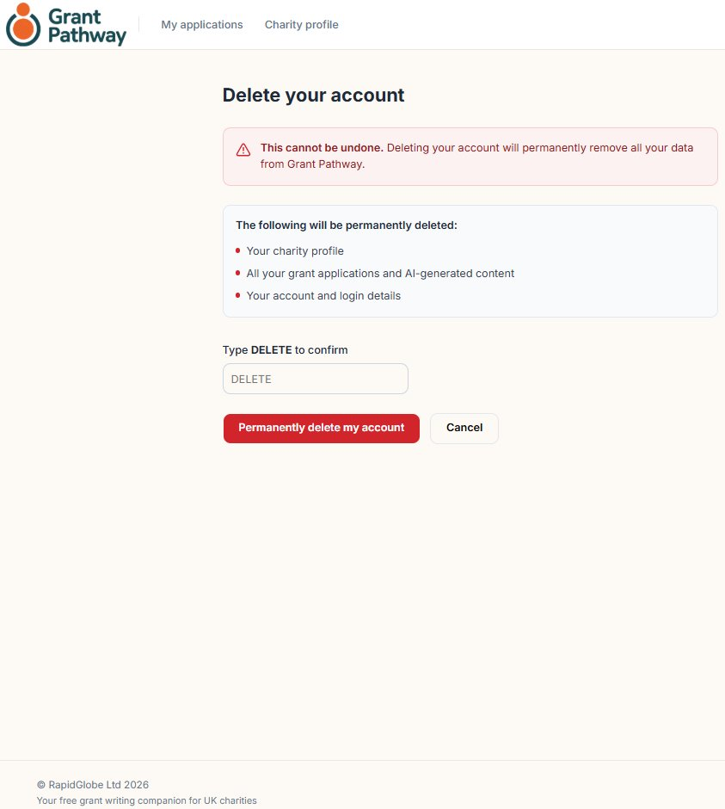
Account deletion is confirmed on screen.
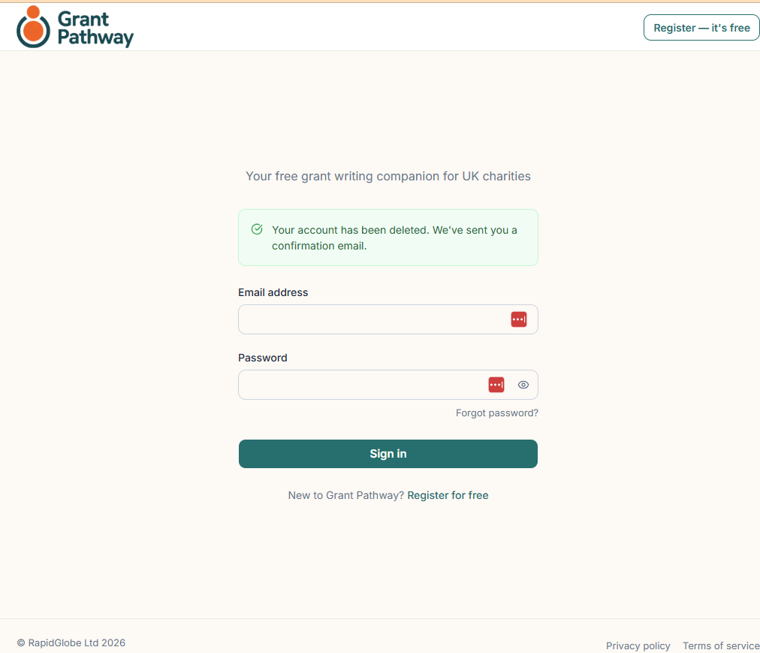

Followed by email confirmation.
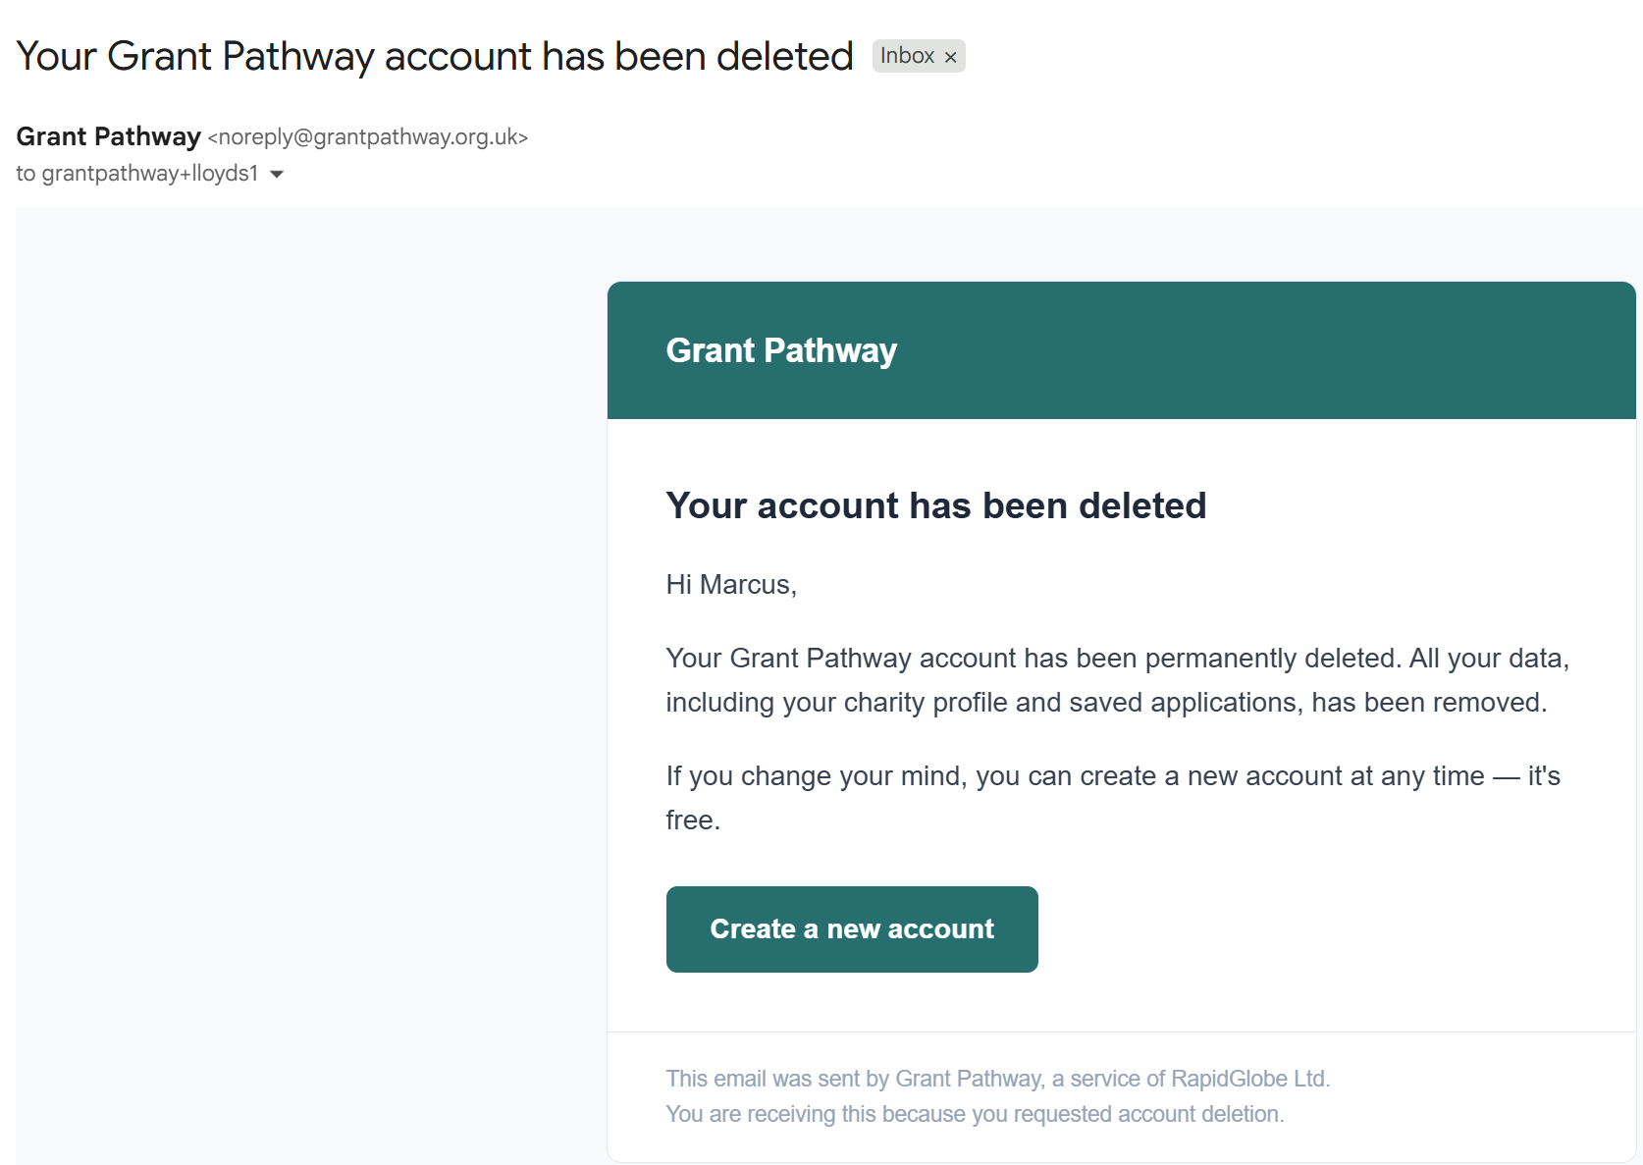

18. Application Status — What the Labels Mean
Each application on your dashboard displays a status label showing where it is in the process.
- Not started — the application has been created but no answers have been entered yet.
- In progress — answers have been started but not all sections have been approved.
- Approved — all answers have been approved and the application is ready to export.
- Exported — the application has been downloaded as a Word document.

19. Need Help?
If you have a question or run into a problem, contact the Grant Pathway team at:
wjokhia@rapidglobe.com
Please include a brief description of the issue and, if possible, the name of the funder you were working on.

